I completed the task in the following steps:

#### **1. Project Setup**

* Created a Maven project named “LibraryManagement” using VS Code.
* Set the correct project structure under src/main/java and src/main/resources.

#### **2. pom.xml Configuration**

* Added the *spring-context* dependency (version 6.2.8 for Java 17+ compatibility).
* Configured the *exec-maven-plugin* to run the Main class.

**3. Bean Definitions in applicationContext.xml:**

*follow WEEK3\LibraryManagement\src\main\resources\applicationContext.xml*

* Defined a *BookRepository* bean.
* Defined a *BookService* bean and injected the repository using setter injection.

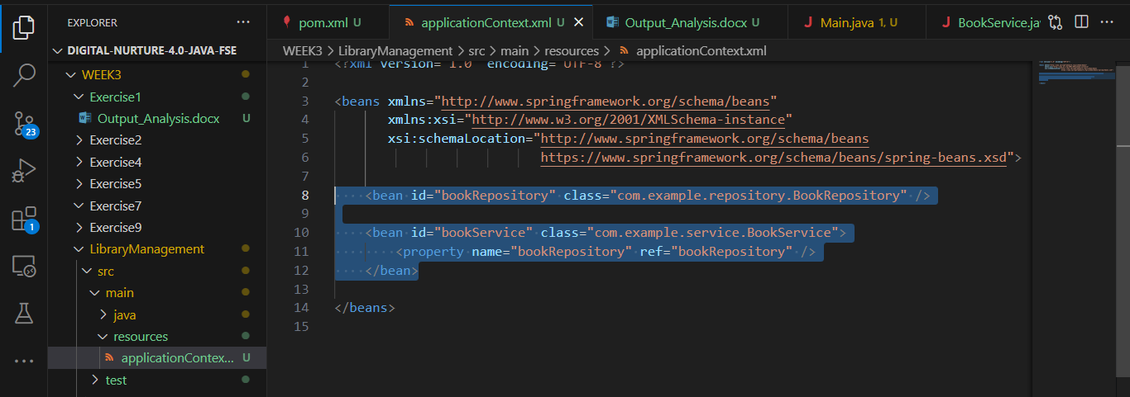

4. **Implemented Classes:**

* *BookRepository* had a *saveBook(String title)* method to simulate storing a book.
* *BookService* had a *setBookRepository()* setter for injection and an addBook(String title) method that called *saveBook().*

4. **Implemented Classes:**

* BookRepository path:*WEEK3\LibraryManagement\src\main\java\com\example\repository\BookRepository.java*
* BookService Path: *WEEK3\LibraryManagement\src\main\java\com\example\service\BookService.java*

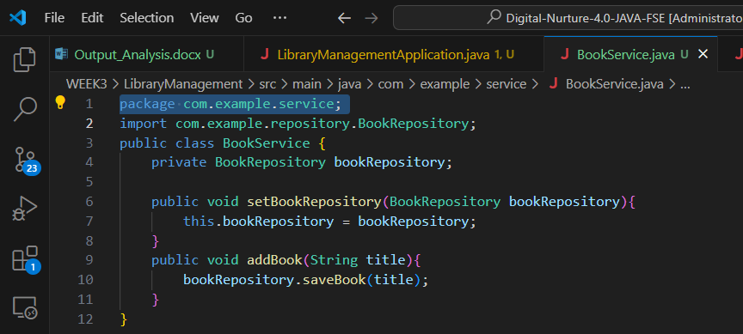

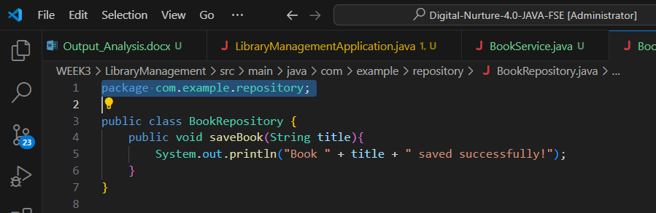

#### 

#### **5. Main Application**

* Created Main.java in com.example.controller.
* Loaded the Spring context using *ClassPathXmlApplicationContext*.
* Fetched bookService bean and called addBook("Secret History of Mongols").

**Output(Screen shot):**

